# Project Phasing

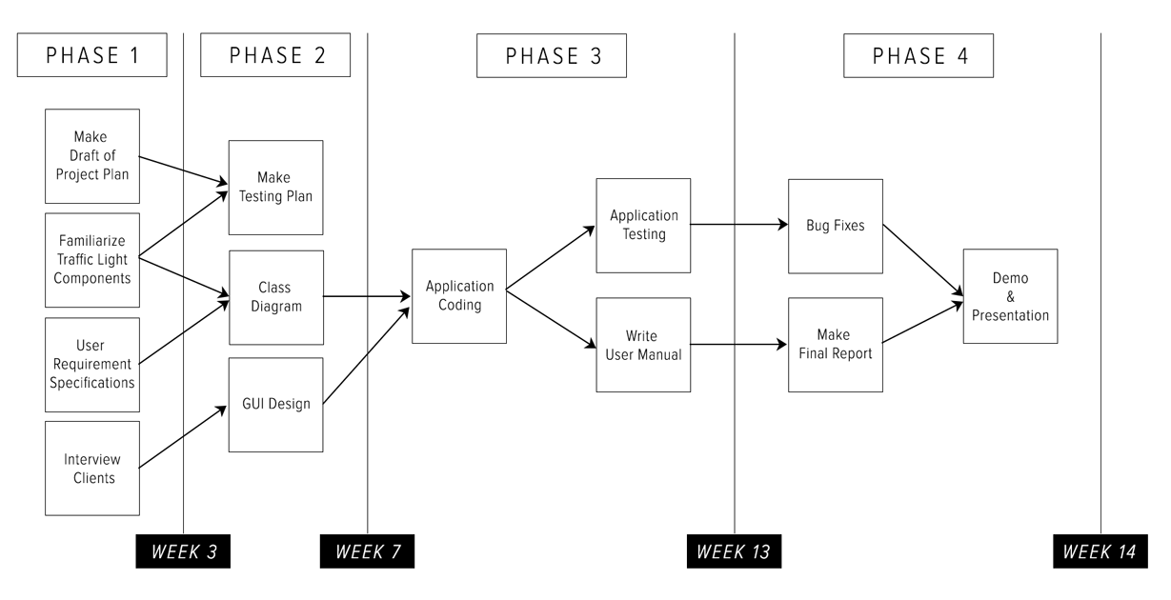

## Phase 1: Requirement Gatherings

Activities of this phase are:

1. Make a Draft of Project Plan
   1. Project Statement
   2. Project Phase
   3. MOSCOW
2. Familiarize Traffic Light Components
3. User Requirement Specifications
   1. Uses Cases
   2. Function Requirements
   3. Non-Function Requirements
4. Interview Client
   1. Create Questions

Deliverables for milestone **P1** are:

1. First Draft Project Plan
2. URS

## Phase 2: Initiations

Activities of this phase are:

1. Make Testing Plan scenarios
2. Class Diagram
   1. Discuss Class Diagram
   2. List every class with description
3. GUI Design
   1. Create GUI Sketches of the application

Deliverables for milestone **P2** are:

1. Test Plan
2. GUI Sketches & Wireframe
3. Class Diagram

## Phase 3: Building

Activities of this phase are:

1. Coding the application
2. Test the application
3. Write the manual

Deliverables for milestone **P3** are:

1. C# Application
2. User Manual
3. Testing Report

## Phase 4: Finalization

Activities of this phase are:

1. Bug Fixing
2. Make Final Report
3. Demo & Presentation

Deliverables for milestone **P4** are:

1. Final Report
2. Final Version of C# Application